Database Name:encryption

Table name:register

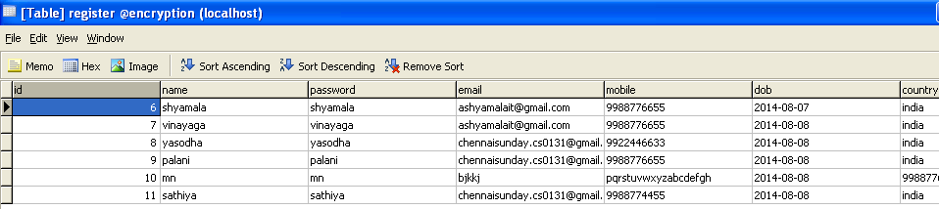

Table name:user

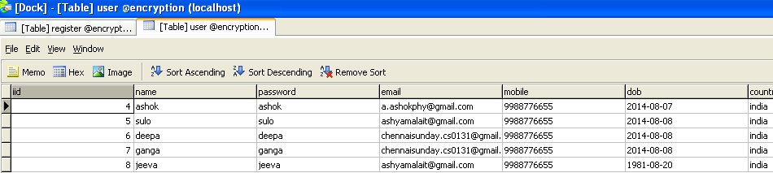

Table Name:files

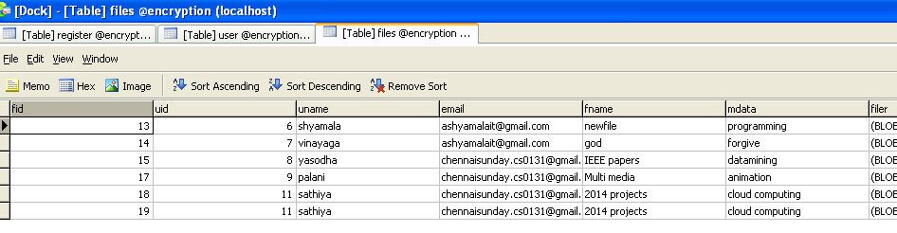

Table name:request

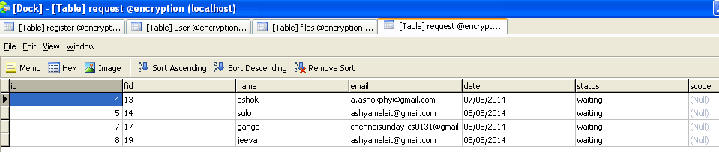

Table name:request1

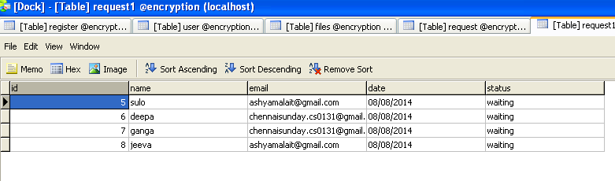

Table name:timer

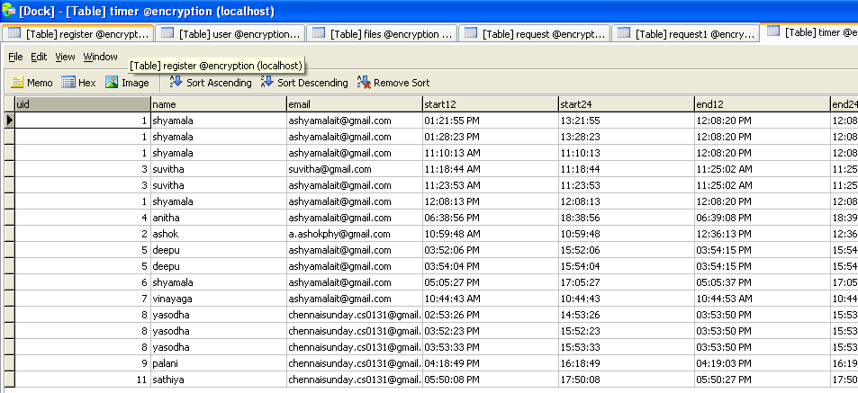

Table name:downs

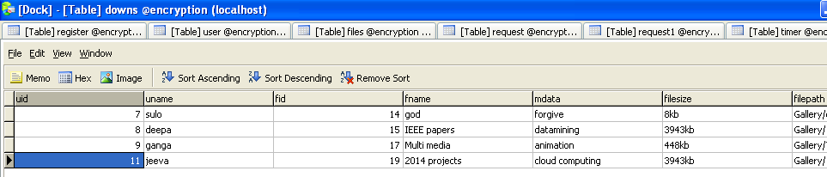

Table name:downs1

